**Application for Admission for the 5783-84 (2023-24) School Year**

**Entering Grade ________**

**STUDENT INFORMATION**

STUDENT’S NAME

Last First Hebrew 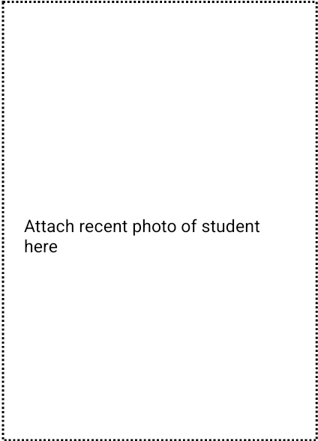

DATE OF BIRTH_________________ PLACE OF BIRTH____________________________

HOME ADDRESS_____________________________________________________________

CITY____________________________ STATE________ZIP__________________________

HOME PHONE____________________________

**FAMILY INFORMATION**

FATHER’S NAME ________________________EMAIL_____________________________

WORK PHONE____________________CELL PHONE_______________________________

COMPLETE ONLY IF DIFFERENT FROM STUDENT’S INFORMATION

HOME ADDRESS___________________________________________________________

CITY_____________________________STATE_________ZIP_______________________

MOTHER’S NAME____________________________EMAIL________________________

WORK PHONE______________________CELL PHONE____________________________

COMPLETE ONLY IF DIFFERENT FROM STUDENT’S INFORMATION

HOME ADDRESS___________________________________________________________

CITY_____________________________STATE _________ZIP______________________

**EDUCATION**

**Please list the name & address of ALL schools attended (list most recent school first)**

_____________________________________________________________________________________

Name Address Grade From To

_____________________________________________________________________________________

Name Address Grade From To

_____________________________________________________________________________________

Name Address Grade From To

**\*\*\*\* APPLICATION CONTINUES ON BACK \*\*\*\***

**OTHER INFORMATION**

Congregation with which family is affiliated__________________________________________________________

Name and phone number of Rabbi who is closest to family_______________________________________________

Name and phone number of previous teacher who would recommend student ___________________________

_______________________________________________________

**ADDITIONAL FAMILY INFORMATION**

**OTHER CHILDREN IN FAMILY**

Name Age Grade School or College Attending

1. _________________________________________________________________________________________
2. _________________________________________________________________________________________
3. _________________________________________________________________________________________
4. _________________________________________________________________________________________
5. _________________________________________________________________________________________

**PARENT CERTIFICATION**

I hereby apply for admission to Mesivta Birkas Yitzchok for my son __________________________________

who will be entering Grade ____ for the 2023-24 school year. I authorize any school attended by my son to release to MBY all academic (report cards, standardized testing etc.) and financial records**. *I am enclosing a $100 non-refundable application fee.***

______________________________________________ ________________________

Father’s Signature Date

______________________________________________ ________________________

Mother’s Signature Date

6022 West Pico Boulevard

Los Angeles, CA 90035

323-937-4748 Fax: 323-937-4782

office@mbyla.org